
UNITED WAY
of the CAPITAL AREA
Serving Hinds, Madison and Rankin Counties

For Immediate Release Contact: Jean C. Frazier
October 28, 2022 jean@myunitedway.com
601.948.4725
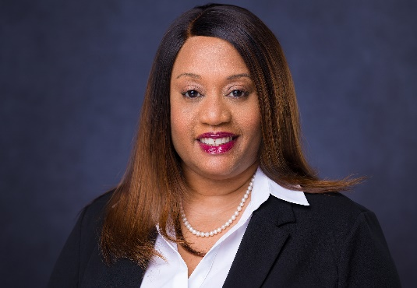
UNITED WAY APPOINTS NIKKI MCCELLEIS AS PRESIDENT AND CHIEF EXECUTIVE OFFICER

(Jackson, MS) -- United Way of the Capital Area announced today that Nikki K. McCelleis has been appointed as the permanent president and Chief Executive Officer of the company. An experienced leader and consummate professional, McCelleis succeeds Ira Murray and assumes the leadership responsibilities effective September 1, 2022.

Nikki K. McCelleis has worked for United Way for 6 years and served in a myriad of capacities that have prepared her to lead the 6-member organization. Under her leadership as Director of Alignment Jackson, McCelleis made improvements that led to academic support program for high school students that led to an increase in the literacy achievements and matriculation rates among high school students. As Vice President of the Community Impact Initiative, she steered the successful organization of the Young Professional Leaders. McCelleis also served Director of Educational Initiatives and Chief Impact and Strategy Officer where she was most strategic in organizing and engaging the key constituencies of Hinds, Madison and Rankin counties in their
key areas of interest parallel to the initiatives of the United Way.

“We are excited to appoint Nikki McCelleis as our permanent President and Chief Executive Officer for United Way,” said Dr. Ivye Allen, Chair of the Board for United Way of the Capital Area. “Nikki’s tenured work with us coupled with her extensive background in community organizing should help us strengthen and advance our partnerships while further developing our strategic initiatives.”

Prior to joining United Way, McCelleis served as Executive Director for 100 Black Men of Jackson, Inc. In addition, McCelleis spent nearly 9 years serving as the Deputy Executive Director for Education at Mississippi Pubic Broadcasting where she was responsible for the development of Early Childhood Literacy and K-12 educational services, resources and outreach initiatives, instructional production, statewide technology integration programs, dropout prevention initiatives, professional development opportunities for educators, the Mississippi Interactive Video Network (MIVN), and continuing education opportunities for adults.

843 North President Street│ Post Office Box 23169│ Jackson, MS 39225-3169│ 601.948.4725
McCelleis also served as Division Director for Curriculum and Instruction at the Mississippi Department of Education. While at the Mississippi Department of Education, McCelleis also served as Division Director in the Offices of Evaluation and Enhancement and Instructional Support and Training where she led efforts to support schools deemed as low performing and at-risk.

“Ms. McCelleis brings to United Way a unique blend and mastery of experiences as a former teacher, a grant developer and director of several non-profit organizations,” said Gus McCoy, Senior UWCA Board Member and employee of the Centene Corporation. “We value these relationships as they intersect with our key program interests in education, health and financial stability for the families and communities of Hinds, Madison and Rankin counties,” added McCoy.

McCelleis also served as Division Director for Curriculum and Instruction at the Mississippi Department of Education. While at the Mississippi Department of Education, McCelleis also served as Division Director in the Offices of Evaluation and Enhancement and Instructional Support and Training where she led efforts to support schools deemed as low performing and at-risk.

McCelleis taught in Jackson Public School District and Hollandale School District. She also served as a Job Specialist with Jobs for Mississippi Graduates. Additionally, McCelleis has served as an Educational Consultant for state and local agencies, nonprofits, and various school districts. She also held the position of Equal Business Opportunity (EBO) Officer with the City of Jackson.
McCelleis is a graduate of Murrah High School; received an Educational Specialist Degree in Educational Administration and Supervision from Delta State University, a Master of Arts in Curriculum and Instruction from Belhaven University and holds a Bachelor of Arts in English Education from the University of Southern Mississippi.
Nikki is married to Michael T. McCelleis, a Captain with the Jackson Fire Department, and is the mother of two children, Nicholas Mekhi, 19 years old, and Malia Ylonne, 13 years old.

##

